Compliance Software Data

Compliance Software Data Overview
There are three main categories of data required to perform the ECB compliance processing, including:

n Compliance Rules data,
n User Inputs (defined both interactively and in ASCII text files), and
n Simulation Engine data.

The compliance rules are pre-processed by the rule authority using the rules compiler into a single binary compliance rules file. A series of steps will be taken by the rules compiler as the ASCII rules files are converted into the binary rules file to prevent end-users from tampering with the compliance rules. The resulting binary rules file will then be distributed to the ECB Compliance Software end-users for use in their compliance analysis projects. Figure 3-1 illustrates the process of taking many types of ASCII rules data (developed by rule authorities) and compiling that data into a single binary rules file for distribution to end-users.

The process of compiling the compliance rules into a single binary file will be transparent to the users of the ECB Compliance Software since this task is performed by the rule authority. There is, however, a significant amount of additional data which will go into each compliance analysis run. Some of these data will be distributed with the software, in the form of weather files that are compatible with the simulation engine and other data/configuration files that are editable by the user. However, the majority of the input data generated for a compliance analysis will be created by the user within the user interface module of the ECB Compliance Software. Figure 3-2 illustrates the types of data which are used by and outputted from the ECB Compliance Software.

Figure 3-1: Compiling Compliance Rules Into Binary Format
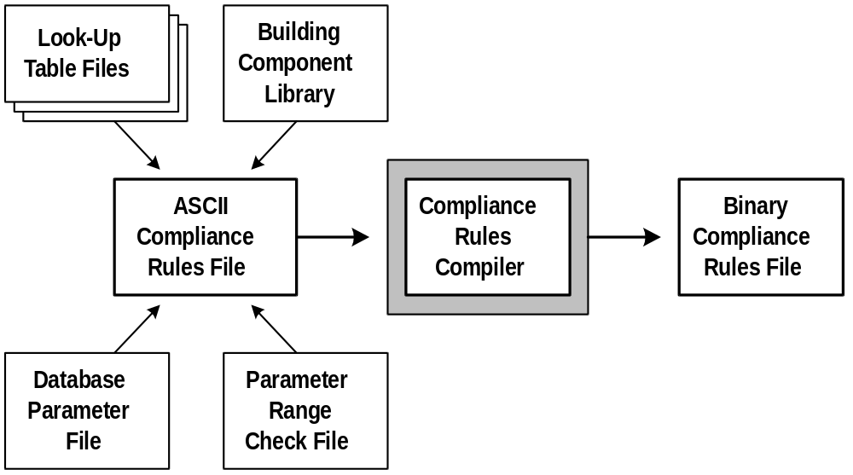

Figure 3-2: Data Flow Through The PNNL ECB Compliance Software
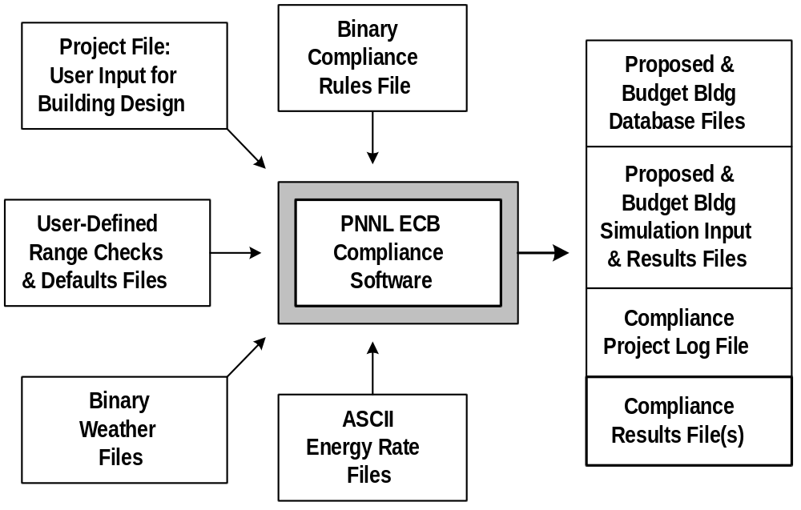
The following sections provide a more in-depth description of each type of compliance software data contained in the previous diagrams.

Compliance Rules Data
The compliance rules input files are ASCII text files and they are depicted in the left-hand portion of Figure 3-1. These files make up the entire collection of inputs to the compliance rules compiler module. The formats of these files are designed to make creation and maintenance of compliance rulesets as simple as possible for rule authority organizations. There are several different types of data required to describe a compliance ruleset, and each ASCII file contains one of the data types. This also prevents any single rules file from becoming so large that it becomes difficult to manage. Documentation describing the format of each compliance rules input file can be found in the topmost section of each file.

The output resulting from the successful compilation of the ASCII compliance input files is a single binary encrypted rules file. This one file contains all of the information contained in ASCII input files, but in an encrypted format which effectively prevents the end user from modifying the compliance rules.

The following paragraphs describe the ASCII input files to the rules compiler and the single binary encrypted output file.

ASCII Compliance Rules File
The main ASCII compliance rules file contains references that identify the remaining ASCII files required to describe the compliance ruleset. This file also contains the actual expressions which model each compliance rule. The rule expressions are defined in several lists ordered as required by the compliance analysis and the building database.

The ASCII compliance rules file which describes the rules defined in California’s Alternative Calculation Method (ACM) Approval Manual is called rules.txt and can be found in Appendix B, Subsection 1.

Look-Up Table Files
Each compliance ruleset can reference one or more tables of data. The use of tables is often the most convenient way to integrate conditional data. These files can contain any number of both independent and dependent data arranged in columns. This format is consistent with tables of building description inputs provided in many compliance rule documents. All look-up tables are first referenced in a tablelist near the top of the main ASCII compliance rules file, as demonstrated by the following excerpt from the main ACM compliance rules file:

TABLELIST
OccupAssumpTable( "occassum.txt", 1, 8 )
WallTable( "wall.txt", 5, 1 )
WindowTable( "window.txt", 3, 2 )
SystemTypeTable( "system.txt", 5, 1 )
PumpMotorTable( "motors.txt", 1, 3 )
END

Each look-up table reference starts with a character string which will be referenced throughout the compliance rule expressions as if it were a predefined function. Within the parenthesis is the name of the file which contains the look-up table data, the number of columns of data which are independent variables (search parameters) and dependent variables (return data). For example, the first look-up table provided in the tablelist can be referenced throughout the compliance rule expressions as OccupAssumpTable. The data contained between the parenthesis’ indicate that (a) the look-up table data can be found in the file named occassum.txt, (b) there is one independent variable column, and (c) that there are eight dependent data columns.

Throughout the compliance rule expressions, data contained in the look-up tables can be referenced by indicating the table name followed by parenthesis’ containing look-up values for each independent variable in the table and an index into the dependent variable columns.

Appendix B, Subsection 4 contains examples of several ACM look-up tables.

Building Component Library
Each compliance ruleset can reference a single library which contains any number of building components which may be referenced by the compliance rule expressions. This file is formatted very much like the ASCII files which store the user input for building description data. The main difference is that the library is made up of a collection of building components which do not describe a single building or project, but instead describe a wide variety of schedules, equipment performance curves, and any other components which are specifically defined by the compliance ruleset.

Appendix B, Subsection 5 contains an example of the building component library developed to support the ACM compliance ruleset.

Database Parameter File
The file containing database parameters provides information corresponding to each individual parameter which can be used to describe the building being tested for compliance. Several of the data elements are flag values which are set to the integer value 0 for false or 1 for true. This data includes:

n Compliance data type classification (Compulsory, Required, Optional, Default, Critical Default, Prescribed or NotInput).

n A flag indicating whether or not this parameter is a primary variable (an independent variable upon which other parameters describing the same building component depend).

n A flag indicating whether or not the parameter can be edited by the user from within the user interface. This flag should be set to true for all parameters which must be input by the user and should be set to false for all parameters whose values are prescribed by the compliance rules.

n A flag indicating whether or not the user may assign a user defined default value to the building database parameter. Utilizing user defined default values can help automate user input of the building description, but can also increase the chances of errors being made in the input description, since the user doesn’t have to specifically input each individual value and may overlook improperly defaulted values.

n Three flags indicating whether or not the user interface will display the parameter in any of the three interface modes, including Input, Proposed and Budget. When in Input mode, the user interface displays and allows editing of the building inputs. When in the Proposed or Budget modes, the user interface displays the final proposed and budget building parameter values, but typically does not allow editing of these values.

Appendix B, Subsection 2 contains an example of the Database Parameter File developed for the ACM compliance ruleset.

Parameter Range Check File
In order to help guide the user and prevent the input of errant data, the compliance ruleset can define a series of range checks to be performed on any data input or modified by the user. The data describing each individual range check include:

n The name of the parameter for which the range check is defined.

n A flag indicating whether the range check value represents a minimum or a maximum value.

n A range check classification value, including Message, Warning and Error.

n The floating point range check value.

n A message which provides an explanation of the range check violation.

In the event the user enters a value which causes a range check violation, the violation message is both displayed to the user and written to the project log file (no matter what the range check classification (Message, Warning or Error)). If the range check is classified as Warning or Error, then the message is also written to the compliance results and if the range check classification is Error, then the user interface will not allow the compliance processing to begin.

Appendix B, Subsection 3 contains an example of the range check file developed for the ACM compliance ruleset.

Binary Compliance Rules File
This file results from the successful compilation of the ASCII compliance input files described above. This file is written in an encrypted binary format in order to prevent the end user from modifying the compliance rules defined therein. This is the only source of compliance rules data referenced by the PNNLComply modules which perform compliance testing (as opposed to the compliance rules processor which is used only to create the binary rules file). This input file is imported into the compliance module of the software during program initialization and the compliance module then provides the user interface and building database modules with access to these data via exported functions from the compliance module.

PNNLComply Software Data
The data which are utilized by the PNNLComply software in order to perform compliance analysis is displayed in Figure 3-2. The majority of these data need only be prepared once, and can be utilized repeatedly for different compliance analyses. The only data pictured in Figure 3-2 which must be created specifically for each compliance analysis project is the data labeled User Input of Proposed Bldg Design. Each of the compliance software inputs and outputs are described in the following paragraphs with the exception of the Binary Compliance Rules File, which is described in the previous section as the output from the compliance rules compiler.

Project File: User Input for Building Design
The first and probably most time consuming step in performing compliance analysis on a building is to describe the building to the compliance software. The PNNLComply user interface allows the user to perform this task with minimal effort, but the fact remains that the building must be correctly described in order to perform an accurate compliance analysis. In order to describe the proposed building design, the user may either start from scratch or retrieve an existing building and alter it to properly describe the building being analyzed. At any point in the process of describing the building, the user may save the inputs to an ASCII text project file, for later retrieval and completion.

Only the data that the user has actually entered will get stored in the Project Input File. All parameters for which the user has accepted the program or user defined defaults will not get written to the building description, in order to allow future versions of default values to populate these data elements during future analyses.

User-Defined Range Checks & Defaults Files
The user will have access to two ASCII files which provide the user interface with range checks and default values. These checks and defaults allow the user to customize the way the interface handles data input by the user which in turn helps to automate the process of describing the building being analyzed. The user-defined range checks are executed only in the event the data input by the user have passed any range checks defined in the compliance ruleset. Similarly, the user-defined default values are only taken into account for those parameters which do not have prescribed or default values already defined in the compliance ruleset.

Binary Weather Files
In order to perform the hourly simulation step of the compliance analysis, the software must have access to hourly weather data which is compatible with the simulation engine. Since the software is originally going to be developed using DOE-2 as the simulation engine, the weather files must be in the packed binary DOE-2 format. Information on this format can be found in the DOE-2 simulation engine documentation.

ASCII Energy Rate Files
Since energy rates are so rarely altered, it was decided that the interface need not provide automated access to these inputs. Instead, the user will be able to select from one or more predefined energy rate files to be used in the compliance analysis. These rate files can be distributed to the end users with the compliance software or may be made available by the local utility company or may be created by the end user. The compliance results will echo certain energy use and/or energy rate information in order to prevent the user from performing the analysis with incorrect rate files.

This concludes the description of the compliance software inputs. The following paragraphs provide information regarding the files which are stored by the user interface during the course of performing the compliance analysis.

Proposed and Budget Building Database Files
Once the user has completed the input of the building description and selects the button to begin the compliance analysis, a brief check is performed on the building description to confirm that all the necessary components are present for conducting the building simulation. If all components are present, the compliance analysis continues by applying certain compliance rulelists in order to finalize the proposed building description. Once these steps are completed, the compliance module stores an ASCII file containing the proposed building description. The compliance module then performs the proposed building simulation.

These compliance module converts the proposed building description to the budget building by applying other rulelists to the proposed building description. Once the budget building description is finalized, this description is stored in another ASCII file before the budget building is simulated. Each of these files can be reviewed later using the compliance software user interface or any ASCII text file editor.

Proposed and Budget Building Simulation Input and Results Files
Immediately prior to performing the proposed and budget building simulations, DOE-2 simulation input files are generated by the simulation module. These files can either be stored for future reference, or may be removed following the simulations depending on an option available to the user. The results from the proposed and budget building simulations are stored in DOE-2 results files. These results files are read by the simulation module in order to apply certain compliance rules, such as those which confirm HVAC systems sizes and test for the proposed building energy costs being less than or equal to the budget building costs.

Compliance Project Log File
A separate log file will be generated for each compliance project. These log files will store a wide variety of information, such as range checking violation messages, explanations of errors encountered during the course of applying compliance rules, dates and time of project retrieval, storage, and each compliance analysis step. These files may become quite large for projects which have a lengthy history of analyses, so it will be the users responsibility to periodically delete or rename the log file in order to begin a new log file.

Compliance Results File
The compliance results file contains the final compliance analysis results. The exact format of this file is as yet undefined, but the development team is currently investigating the possibility of storing these files in Rich Text Format (RTF). RTF files include not only text characters, but also a wide variety of line, font and paragraph formatting commands which, when imported into RTF-compatible word processors, display the results in a nicely formatted, professional manor. The development team is also looking into the incorporation of an RTF-compatible multi-line edit control which would be capable of displaying the results file in the same professionally formatted manor.

Results file security becomes an issue if the RTF format is adopted, since this file is ASCII and can therefore be easily edited by the user. In order to provide a reasonable amount of security for these files, the development team is considering appending a numeric value to each RTF results file which is the result of a modified checksum operation. If this path is chosen, a small results file verification application would have to be developed in order for the rule authority to confirm the authenticity of the results file.

Compliance Software Data
This section provides a more detailed description of the structure of the building database. The data structures described in this section are organized by topic. The database topics are as follows:

- Object Type Data
- Parameter Data
- Symbolic Value List Data
- Specific Building Parameter Data
- Compliance Rule Data
- Range Checking Data
- User-Defined Default Data

Fore each topic, elements of the data structure are organized by source. The three sources are:

- Defined in Source Code
- Defined in Compliance Ruleset
- User Defined

Refer to Appendix A for more information regarding the specific parameters that are defined in the building database and used to describe the user input, proposed and budget building designs.

Object Type Data
These data define each type of building database object which can be created to describe the building being tested for compliance (i.e. a Space, a Wall, a Window, etc.).

Data Defined in Source Code:

n Object Type ID: A unique integer value which identifies each building object type.

n Short Object Type Name: A character string used to identify the type of building object. These names are used within the context of compliance rule expressions. Example: “EWall” (short for exterior wall).

n Object Type Label: A character string label used to identify the type of building object. These labels are used by the user interface when requesting the user to select from a list of available building objects and when labeling building objects by type in status, warning and error messages. Example: “Exterior Wall”.

n Maximum Number of Objects: An integer value describing the maximum number of objects of a particular type that the user may define to describe the building being analyzed.

n Current Number of Objects: An integer value describing the number of objects of a particular type that are currently defined in the building database.

n Object Parent Type(s): An integer array of (up to 5) values which contains the IDs of all object types which can be a parent to this object type. Example: The object parent type for an exterior wall would be the object type ID of the building space object.

n Object Child Type(s): An integer array of (up to 5) values which contains the IDs of all object types which can be children of this object type. Example: The object child type values for a space would be the IDs for all object types which can be attached to a space, such as exterior, interior and underground walls.

n Starting Parameter ID: An integer value identifying the location of the first parameter used to describe this building object.

n Number of Parameters: An integer value identifying the number of parameters used to describe this building object.

n Building Object Pointer Array Index: An integer value identifying the starting index into the master object pointer array where data for all objects of this type can be found.

Parameter Data
These data describe the building database parameters used by the compliance software. Generally speaking, a building being tested for compliance is defined by a collection of building objects and each building object is defined by a collection of parameters which describe that object type.

Data Defined in Source Code:

n Parameter ID: A unique integer value which identifies each building database parameter.

n Parameter Name: A character string used to identify the building database parameter. These names are used within the context of compliance rule expressions. Example: “EWallHeight” (short for exterior wall height).

n Parameter Label: A character string label used to identify the building database parameter. These character strings are used by the user interface to label user interface controls and to identify building database parameters in the context of status, warning and error messages. Example: “Height”.

n Parameter Data Type: An integer value which identifies the data type of the parameter (i.e. Integer / Float / Symbol / Character String / Object Assignment).

n Number of Values: An integer value which identifies the number of values used to define this database parameter. This value is one for all single values and equal to the number of array indices for those (few) parameters which are defined by an array of values.

n Units Table Index: An integer value which identifies the units type associated with the building database parameter.

Data Defined in Compliance Ruleset:

n Compliance Data Type: An integer value which defines the data type classification provided in the compliance ruleset. These compliance data type values are defined by special character strings in the datatype.dat file and converted to integers during the rule compiling process.

n Is Primary Parameter: A Boolean value defined in the datatype.dat file which indicates whether or not this parameter is classified as a primary variable.

n Is User Editable: A Boolean value defined in the datatype.dat file which indicates whether or not the user may edit this parameter in the compliance software interface.

n User Defined Default Allowed: A Boolean value defined in the datatype.dat file which indicates whether or not a user defined default may be provided for this parameter.

n Display By Mode: An array of three Boolean values defined in the datatype.dat file which indicates whether or not this parameter is displayed in each of the three user interface display modes (user input, proposed design and budget design).

n Range Check(s): An array of 0 or more range checks which cause messages to be presented to the user in the event user input values lie outside the defined ranges. All ruleset-defined range checking errors, as well as warnings and messages, are presented to the user via dialog boxes and are also included in the project log file. All range checking errors halt compliance processing, while warning and other messages allow processing to continue but are included in the compliance results file(s).

User Defined Data:

n Default Value: A default value to be referenced in the event the parameter is not prescribed and no ruleset default is defined.

n Range Check(s): An array of 0 or more user-defined range checks which cause user interface messages to be presented to the user in the event user input values lie outside the defined ranges. All user-defined range checking errors, warnings and messages are presented to the user via dialog boxes and are also included in the project log file. User-defined range checks do not affect compliance processing and are not included in the compliance results file(s).

Symbolic Value List Data
These data describe the various predefined values to which each symbolically defined building parameter can be set (i.e. SpaceOccupancyType = Auditorium, Bank, Bar, ...). Each symbolic value list has associated with it a series of character strings and corresponding numeric values. The user interface displays the character strings to the user in the form of dropdown listbox controls, and upon selection by the user, the corresponding numeric value is set in the building database. The symbolic list elements that are presented to and can be selected by the user can depend on one or more other building database parameters (i.e. the list of valid SpaceOccupancyTypes can depend on the more general SpaceType parameter).

Data Defined in Source Code:

n Parameter ID: An index identifying the building database parameter for which this list of character strings and values are the predefined, valid values.

n Dependent Parameter ID Array: An array of indexes identifying other building database parameters which act as dependent variables. Current values for each of these dependent variables are referenced by the interface to determine what subset of predefined symbolic values are valid options for user selection.

n Symbolic List Data: An array of one or more structures containing the following components:
Ä An array of dependent variable values (if any dependent variables exist),
Ä A list of character strings and corresponding numeric values which are valid inputs based on the currently defined dependent variables.

Specific Building Object Data
These data describe each individual building database object which can be created to describe the building being tested for compliance.

User Defined Data:

n Object Name: A character string (unique to that object) which identifies the specific building database object.

n Parent Object Pointer: A pointer to the building database object to which this object is attached (i.e. the parent object pointer for an exterior wall points to the space to which that wall is assigned).

n Child Object Pointer Array: An array of pointers to the building database objects which are assigned to this object (i.e. the child object pointer array for a space contains pointers to all the walls that are assigned to it).

Data Defined in Source Code:

n Is User Defined: A boolean value which is set to true for all building objects defined by the user or imported from compliance project files. The source code will set this value to false for all building objects imported from the compliance ruleset data.

Specific Building Parameter Data
This is the lowest level of user input data. These data are present for each individual building database parameter that describes an individual building object.

User Defined Data:

n Data Status: A short integer value which indicates the status of the building database parameter (i.e. default value vs. prescribed value vs. user input).

n Value: A float number which contains the current value of the building database parameter. For symbolically defined parameters, this float value is equal to the numeric value which corresponds to the currently defined user selection.

n Critical Default Comment Index: A short integer 1-based index into the array of critical default comments. The default value of 0 indicates that no comment has ever been entered for this value. A positive index indicates that a comment currently exists. If the user restores the default value, this index is multiplied by negative one in order to provide later access to the same comment in the event the user chooses to overwrite the default value again in the future.

Compliance Rule Data
These data define the rules in a compliance ruleset. Elements include tables of data values and schedules, special ruleset identifying character strings, and several groups of compliance rules. For more information on the contents and format of these files, see Appendix B.

Data Defined in Compliance Ruleset:

n Character String Labels: One or more character string labels used by the user interface and results reporting modules to identify the active compliance ruleset.

n Lookup Tables: Ascii text files which contain lookup tables. These tables have been separated from the main compliance rules file in order to provide the most intuitive, simple and least cluttered input of the compliance rules.

n Building Object Library: An ascii text file which contains a collection of building objects which are entirely defined within the scope of the compliance ruleset. The format of these building object definitions shall be consistent with the format of building objects read from and written to compliance project files.

n Database Parameter Classifications and User Interface Flags: Data classifying each database parameter as one of several predefined compliance datatypes (i.e. Compulsory, Required, Optional Default, etc.). The user interface flags define whether or not the user may edit or provide user-defined defaults for the parameter. These flags also define whether or not the parameter is displayed in any of the three interface display modes.

n Range Checks: A series of range checks for each building database parameter. These checks are performed on the user inputs to help catch input errors and inform the user of such conditions. Unlike the user defined range checks, these are outputted to the compliance project log and results file(s) for review by the user and ruleset authority.

n Compliance Rule Lists: A series of rule lists, each of which defines rules to be applied to the building database during a specific stage of the compliance checking process. These stages include:
1. During user input,
2. Directly following user input of the proposed design,
3. Following proposed building design-day simulation (HVAC system sizing),
4. Prior to the full 8760 hour simulation of the proposed building,
5. Converting proposed building database to budget building database,
6. Following budget building design-day simulation (HVAC system sizing),
7. Prior to the full 8760 hour simulation of the budget building, and
8. Test for final building compliance.

The contents of each rule defined in these compliance rule lists include:
Ä A building database parameter name and array index (-1 for all),
Ä An operator, usually “=“ but also compatible with “<“, “>“, “<=“ and “>=“,
Ä An expression which is evaluated and either sets the referenced building database parameter or performs a comparison which must return TRUE in order for the compliance processing to continue.

Range Checking Data
These data are defined in two separate ascii text files, containing compliance ruleset and user defined range checking definitions.

Data Defined in Compliance Ruleset:

n Range Check Array: An array of structures, each of which defines a range check on some building database parameter. This structure contains the following data:
Ä Parameter Index: The index of the parameter for which the range check is defined.
Ä Parameter Array Index: A one-based index into the array of values defining the building database parameter for which this range check is defined (only required for those database parameters which are represented by an array of values and a value of -1 causes the range checking to be executed on all array values).
Ä Range Check Type: Either “min” or “max”, defining the type of range check.
Ä Range Check Priority: Either “error”, “warning” or “message”, defining the relative significance of a range checking violation.
Ä Value: The value which sets the limit for the range checking operation. Ruleset defined range checking values can be in the form of expressions.
Ä Message: A character string message presented to the user and written to the project log file and/or compliance results file(s).

User-Defined Data:

n Range Check Array: Exactly the same as the data used in range checks defined in the compliance ruleset with these few exceptions:
Ä Range checking values must be defined as constant values and cannot be defined as expressions.
Ä The ruleset defined range checks take priority over the user defined checks.
Ä Failure of user input data passing user defined range checks does not prevent the successful execution of the compliance analysis.

User-Defined Default Data
These data are defined in a single ascii text file which is retrieved during program initialization.

User-Defined Data:

n User Default Array: An array of structures, each of which defines a single user defined default value. This structure contains the following data:
Ä Parameter Index: The index of the parameter for which the default value is defined.
- Parameter Array Index: A one-based index into the array of values defining the building database parameter for which this default value is defined (only required for those database parameters which are represented by an array of values and a value of -1 causes the default to be applied to all array values).
Ä Range Check Type: Either “min” or “max”, defining the type of range check.
- Value: The default value.
- Messages: ?

